### Visualization of Sorting Algorithms for Enhanced Algorithmic

#### A PROJECT REPORT

***Submitted by***

Karanpreet Singh(22BCS12898)

##### *in partial fulfilment for the award of the degree of*

**BACHELOR OF ENGINEERING**

###### IN

COMPUTER SCIENCE AND ENGINEERING



#### Chandigarh University

JULY-DECEMBER 2024



#### BONAFIDE CERTIFICATE

### Certified that this project report “Visualization of Sorting Algorithms for Enhanced Algorithmic” is the bonafide work of “KARANPREET SINGH” who carried out the project work under my/our supervision.

**SIGNATURE**

**Er. Natasha Sharma**

**SUPERVISOR**

**BE – CSE**

## **TABLE OF CONTENTS**

**LIST OF FIGURES4**

**ABSTRACT5**

**ABBREVIATIONS6**

**CHAPTER 1. INTRODUCTION7**

1.1 Identification of Client/ Need/ Relevant Contemporary issue7

1.2 Identification of Problem7

1.3 Identification of Tasks7

1.4 Timeline8

1.5 Organization of the Report8

**CHAPTER 2. DESIGN FLOW/PROCESS9**

2.1 Evaluation & selection of specifications/Features9

2.2 Design Constraints9

2.3 Analysis and feature finalization subject to constraints9

2.4 Design flow10

2.5 Design selection10

2.6 Implementation plan/methodology10

**CHAPTER 3. RESULT ANALYSIS AND VALIDATION12**

3.1 Implementation of design 12

3.2 Features of Design12

**CHAPTER 4. CONCLUSION AND FUTURE SCOPE OF WORK14**

4.1 Future Scope14

4.2 Conclusion14

# List of Figures

Figure-1.1 Gantt Chart.………………………………………………………………………...….08

Figure-2.1 Implementation plan………………………………………………………………..….11

Figure-3.1 Unsorted array.………………………………………………………….……………..13

Figure-3.2 Sorted array.……………………………………………………………………...…....13

# ABSTRACT

This project presents a Sorting Algorithm Visualizer that offers an interactive platform to help students and developers better understand various sorting algorithms, including Bubble Sort, Merge Sort, Quick Sort, and Heap Sort. The project identifies the need for a practical tool to visually demonstrate how different algorithms behave, enabling users to compare their time and space complexities. Built using modern web technologies such as React and D3.js, the visualizer allows users to adjust parameters like array size and sorting speed, providing real-time feedback on algorithm performance. The tool is designed to enhance algorithmic learning by enabling users to view step-by-step sorting processes in real-time.

The visualizer was tested with different dataset sizes and types, ensuring the accuracy and functionality of the implemented algorithms. It has proven useful in educational settings, allowing users to interact with algorithms, modify input data, and observe their behavior. Feedback from students and professionals validated the project's success in improving understanding and comparison of sorting algorithms. The report further discusses the implementation, testing methodologies, and validation of the visualizer, alongside recommendations for future improvements such as enhanced performance for large datasets and the inclusion of additional sorting algorithms.

**ABBREVIATIONS**

* **UI** – User Interface
* **UX** – User Experience
* **OOP** – Object-Oriented Programming
* **HTML** – Hypertext Markup Language
* **CSS** – Cascading Style Sheets
* **JS** – JavaScript
* **API** – Application Programming Interface
* **D3.js** – Data-Driven Documents (JavaScript library)
* **DOM** – Document Object Model
* **n²** – Quadratic Time Complexity
* **n log n** – Logarithmic Time Complexity
* **RAM** – Random Access Memory
* **CPU** – Central Processing Unit
* **JSDoc** – JavaScript Documentation

**CHAPTER 1.**

#### INTRODUCTION

**1.1. Client Identification/Need Identification/Identification of relevant Contemporary issue**

Sorting algorithms are crucial in both academic settings and professional environments, serving as a foundation for efficient data organization. In education, sorting algorithms like Bubble Sort, Merge Sort, Quick Sort, and Heap Sort are integral parts of computer science curricula. Yet, surveys and studies show that students often struggle to grasp the internal workings of these algorithms. The abstract nature of their operations, combined with traditional teaching methods such as static diagrams or code walkthroughs, makes it difficult for learners to fully comprehend the process. Reports from organizations like ACM and IEEE emphasize a need for more interactive and visual learning tools to address this gap. In industry, sorting algorithms are directly tied to performance and scalability. For example, in e-commerce, databases, and large-scale applications, sorting is used to optimize everything from product recommendations to efficient data retrieval. Inefficiencies in sorting algorithms can lead to slower processing times, higher memory usage, and a negative user experience, especially when dealing with large datasets. With the exponential growth in data, selecting the right algorithm becomes increasingly critical. Thus, the demand for an interactive sorting visualizer extends beyond the classroom, providing value to developers and engineers who need to optimize algorithms for real-world applications.

###### 1.2. Identification of Problem

The primary problem addressed by this project is the challenge students and professionals face in understanding the comparative behavior of sorting algorithms. Many learners find it difficult to distinguish the operational differences between algorithms like Quick Sort, Merge Sort, and Heap Sort when these concepts are presented theoretically. This leads to confusion when trying to apply the right algorithm in real-world applications. Furthermore, current educational tools and resources are often limited to static representations, which fail to convey the dynamic nature of sorting processes. Consequently, there is a need for a tool that bridges this gap by offering real-time visualization of sorting algorithms, allowing users to see how the algorithms manipulate data step-by-step.

###### 1.3. Identification of Tasks

The project consists of several tasks, starting with research to identify the most commonly used sorting algorithms and their real-world applications. Once identified, the next task is to develop the visualizer’s core functionality using modern web development frameworks, such as React and D3.js, for real-time interactivity. Key algorithms like Bubble Sort, Merge Sort, Quick Sort, and Heap Sort must be implemented in a way that allows users to visualize their performance on datasets of varying sizes and characteristics. The third task is to integrate these algorithms with an intuitive user interface that offers customization options, such as array size and sorting speed. Finally, comprehensive testing is required to ensure that the visualizer functions correctly across different datasets, and user feedback must be gathered for potential improvements.

###### 1.4. Timeline

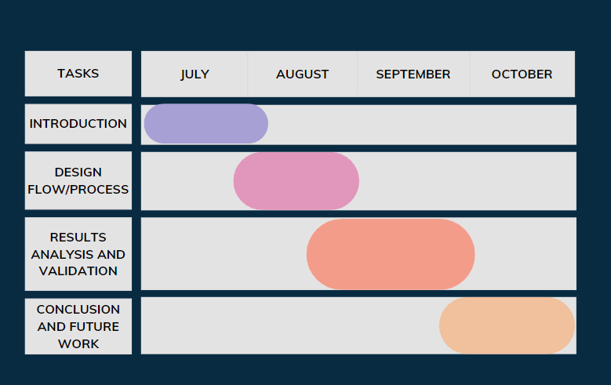Figure1.1 Gantt Chart

###### 1.5. Organization of the Report

* **Chapter 1:** Introduction-
* **Chapter 2**: Design Flow/Process- Covers evaluation of the selected specifications, design constraints, and development flow of the sorting visualizer.
* **Chapter 3**: Results Analysis and Validation- Includes the implementation, results of the visualized algorithms, and comparative performance analysis.
* **Chapter 4**: Conclusion and Future Work- Summarizes findings and suggests improvements for future iterations of the project.

**CHAPTER 2.**

#### DESIGN FLOW/PROCESS

##### 2.1. Evaluation & Selection of Specifications/Features

When designing the sorting visualizer, the team evaluated several key features required for an effective learning tool. The primary feature is real-time visualization of the sorting process, allowing users to observe the step-by-step operation of algorithms like Bubble Sort, Merge Sort, Quick Sort, and Heap Sort. Additionally, the tool needed to support input customization, allowing users to adjust array sizes, data distributions, and sorting speed. This interactivity enables users to see how different datasets affect algorithm performance. Moreover, the visualizer had to be intuitive and user-friendly, catering to both beginner-level students and experienced developers.

Literature reviews and market research helped identify other desirable features, such as the ability to compare multiple sorting algorithms side-by-side. This comparative view is critical for understanding the differences in time complexity and algorithm efficiency. Another important specification was cross-platform compatibility; since the tool would be web-based, it needed to function across multiple browsers and devices seamlessly. After evaluating existing tools, it became evident that the sorting visualizer must also support large datasets while maintaining smooth animations.

##### 2.2. Design Constraints

Several constraints influenced the design of the visualizer. From a technical standpoint, performance was a major concern. Sorting algorithms with high time complexities, such as Bubble Sort (O(n²)), can be computationally expensive for large datasets, resulting in slow animations and poor user experience. This constraint required optimization techniques to ensure smooth functionality even with thousands of data points. Additionally, ethical and professional considerations were taken into account. Since the visualizer is an educational tool, it was essential to design it in a way that adheres to accessibility guidelines, ensuring that users with visual or cognitive impairments can use the tool effectively.

Another key constraint was economic—budget limitations meant that the project had to be developed using open-source technologies and free libraries. This led to the selection of React for the front-end framework and D3.js for the visualization, both of which are well-supported and cost-effective for educational purposes. Finally, social and political factors were considered, particularly regarding data privacy and security. Although the visualizer does not collect user data, it was important to ensure that it operated within a secure web environment.

##### 2.3. Analysis and Feature finalization subject to constraints

After analyzing the project’s constraints, the design team made several adjustments to the initial feature list. To address performance concerns, the visualizer was optimized to handle datasets with up to 1,000 elements without significant lag. This was achieved by employing efficient rendering techniques, including lazy loading for animations. The feature for side-by-side algorithm comparison was refined to include visual markers, allowing users to track the progress of multiple algorithms simultaneously.

Considering the user interface, accessibility features were integrated, such as keyboard navigation and color schemes optimized for colorblind users. Additionally, the design was made responsive to ensure that it functioned well across devices of different screen sizes. Given the budget limitations, the project used open-source libraries like React and D3.js, which not only minimized costs but also ensured long-term support and community contributions. These constraints shaped the final set of features, ensuring a balanced and user-friendly tool that met the initial project goals.

##### 2.4. Design Flow

The design process considered two alternative flows for implementing the visualizer. The first approach was a simple static interface with limited interactivity, where users could run one algorithm at a time. The second approach, which was ultimately chosen, involved a more dynamic interface that allowed real-time interaction, multiple algorithm comparisons, and adjustable parameters such as array size and sorting speed. The dynamic design offered a richer user experience, enabling deeper understanding of how each algorithm behaves.

##### 2.5. Design selection

The dynamic design was selected based on its ability to better meet the educational objectives of the project. Compared to the simpler, static alternative, the interactive interface provided more opportunities for users to engage with the algorithms, offering immediate feedback on how their inputs affected the sorting process. This design also aligned with user feedback from initial surveys, where interactivity was consistently ranked as one of the most important features for a learning tool.

##### 2.6. Implementation plan/methodology

The implementation plan was broken down into several phases. First, the React framework was used to build the core structure of the web application, ensuring that the interface was responsive and intuitive. D3.js was then integrated to handle the real-time animations for sorting. Each algorithm was implemented sequentially, starting with Bubble Sort, followed by Merge Sort, Quick Sort, and Heap Sort. A flowchart of the project’s architecture was created to map out how data would flow through the system, from user input to visualization. The algorithms were written in JavaScript, and each one was thoroughly tested before moving on to the next.

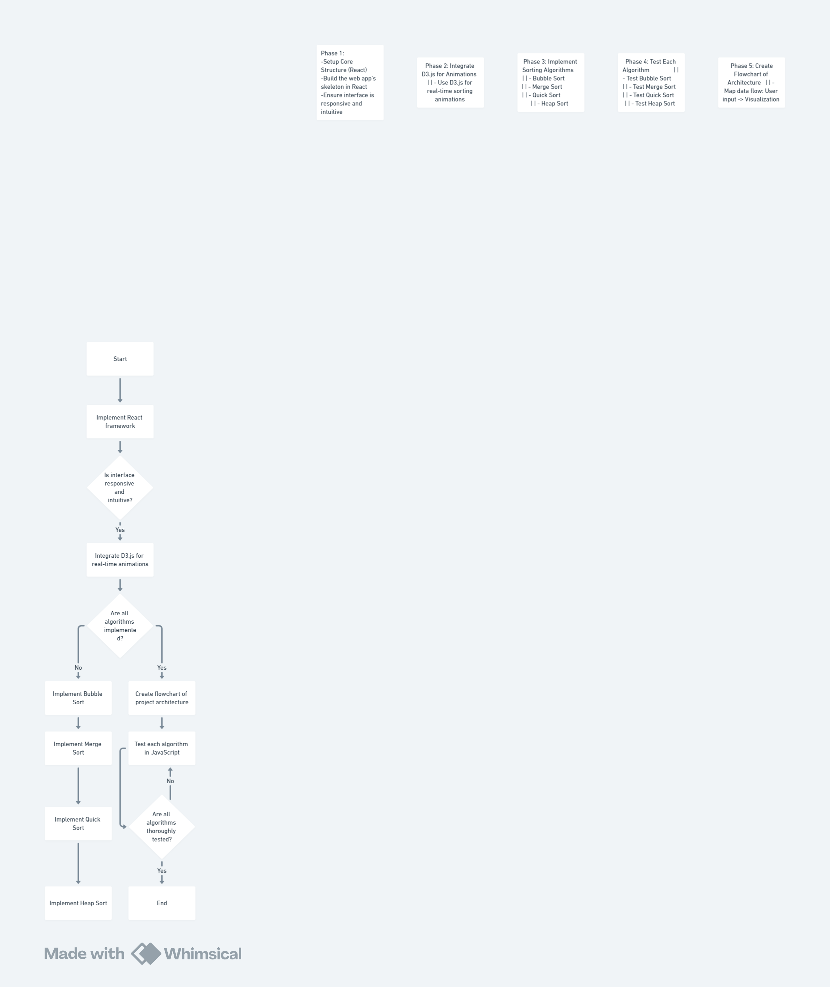

Figure- 2.1 Implementation plan

**CHAPTER 3.**

**RESULTS ANALYSIS AND VALIDATION**

##### 3.1. Implementation of solution

* The sorting visualizer project was successfully implemented using modern web development tools and technologies. React served as the front-end framework, providing a responsive and dynamic user interface, while D3.js was utilized to handle the complex visualizations of sorting algorithms. Each algorithm—Bubble Sort, Merge Sort, Quick Sort, and Heap Sort—was implemented in JavaScript, allowing for seamless integration into the visualizer. The real-time feedback loop was one of the key features that enhanced the user experience, enabling users to adjust parameters such as array size, sorting speed, and the specific algorithm to be visualized.
* Once the algorithms were implemented, extensive testing was conducted to ensure their correctness and efficiency. Different dataset sizes, ranging from small arrays (10 elements) to larger ones (1000 elements), were used to validate the functionality. The performance of each algorithm was analyzed based on time complexity, providing users with clear insights into how each algorithm behaves under various conditions. For example, Bubble Sort exhibited its expected O(n²) time complexity, becoming significantly slower with larger arrays, while Quick Sort and Merge Sort handled larger datasets efficiently, demonstrating their O (nlog n) time complexity.

##### 3.2. Features of solution

1. **Generate New Array** – Allows the user to generate a new set of random numbers that will be sorted by the chosen algorithm.
2. **Array Size & Sorting Speed Adjustment** – A slider that lets users change the size of the array and adjust the speed of the sorting visualization, providing more control over the simulation.
3. **Algorithm Selection** – Multiple sorting algorithms are available:

* Merge Sort
* Quick Sort
* Heap Sort
* Bubble Sort

1. **Visual Sorting** – After selecting an algorithm, users can press the "Sort!" button to watch the algorithm in action, visually showing the sorting process step by step.
2. **Interactive and User-Friendly UI** – The clean and minimalistic interface makes it easy to switch between algorithms, adjust parameters, and initiate sorting.

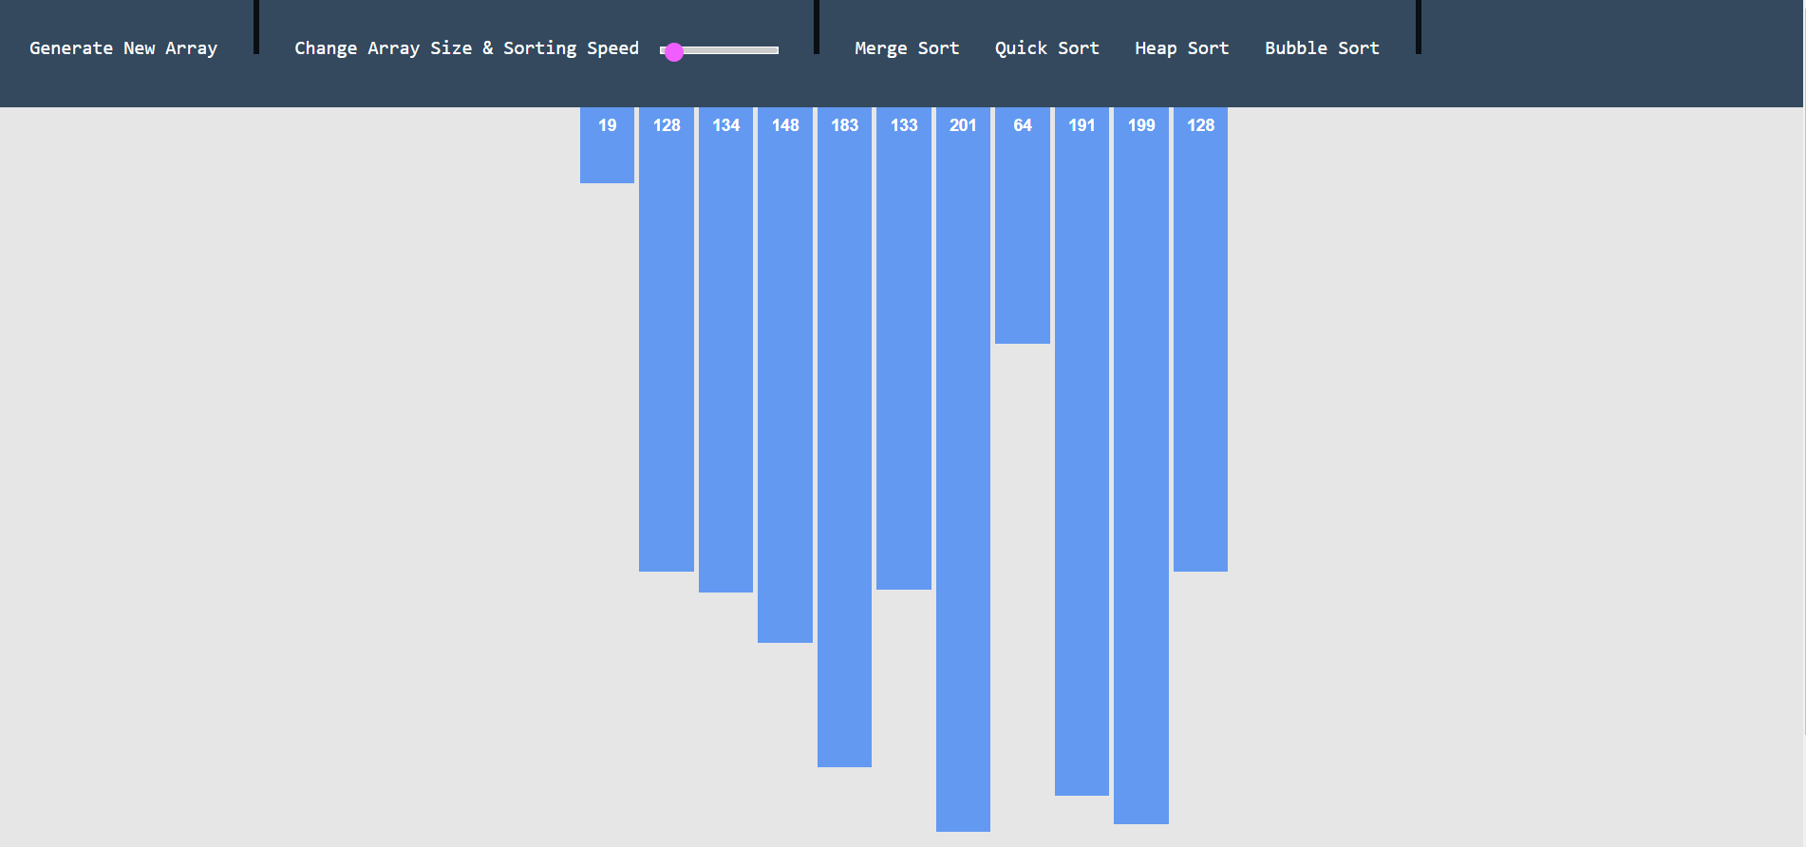

Figure-3.1 Unsorted array

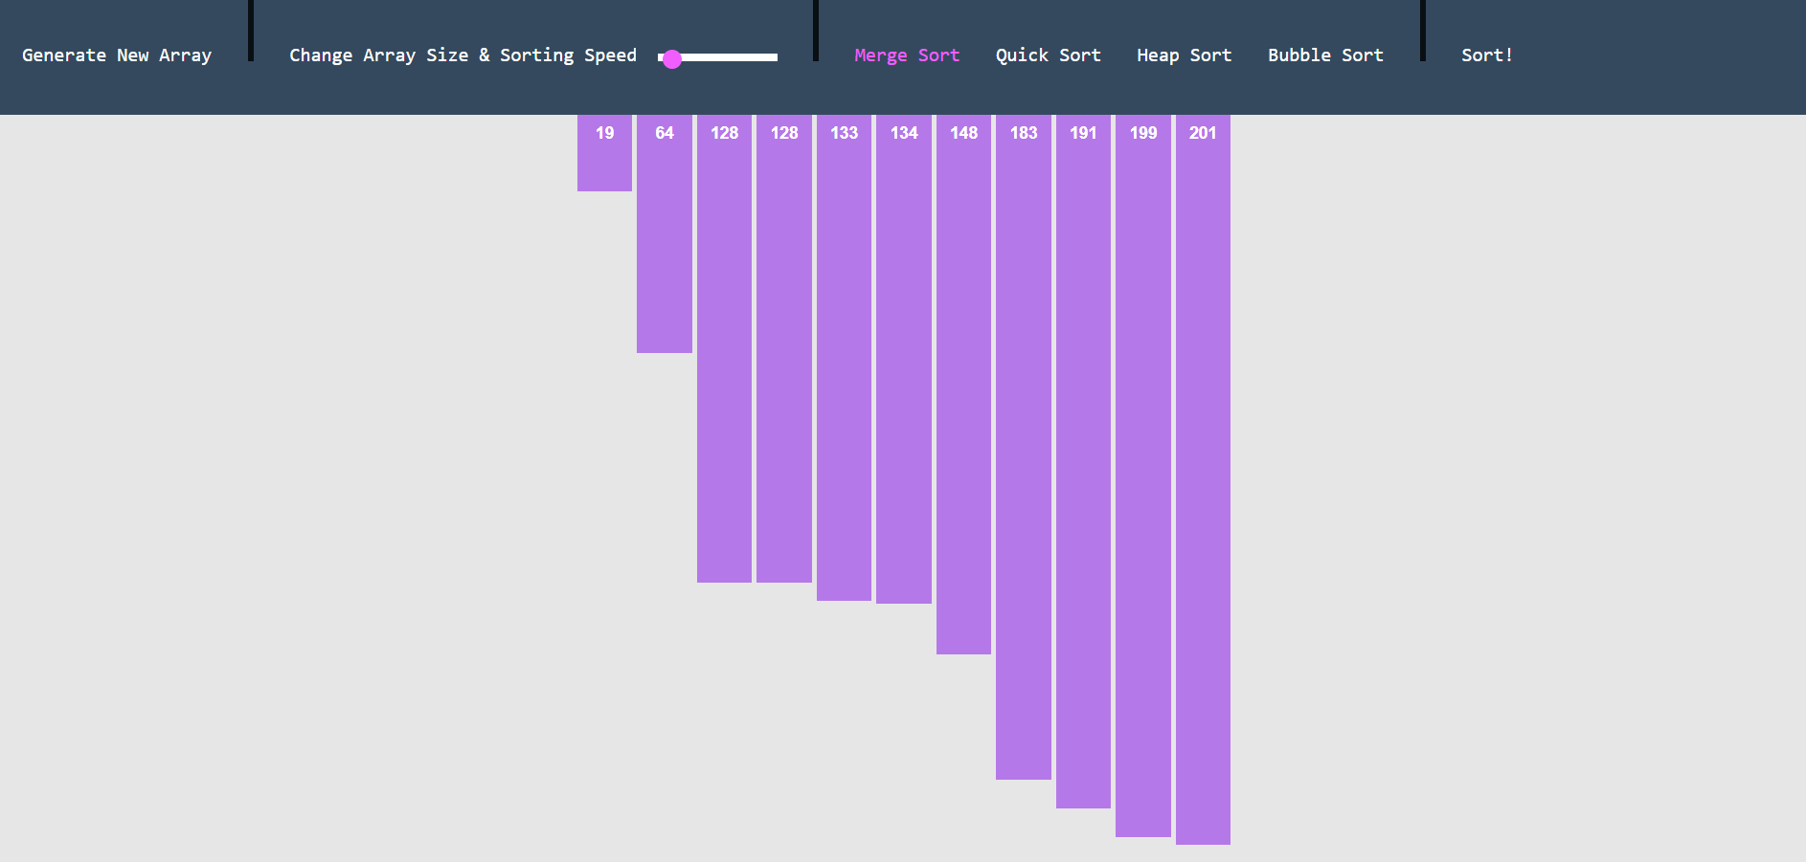

Figure-3.2 sorted array

**CHAPTER 4.**

**CONCLUSION AND FUTURE WORK**

##### 4.1. Conclusion

The sorting visualizer project effectively addresses the need for an interactive, educational tool to help users understand the behavior of various sorting algorithms. By providing real-time visualizations of algorithms such as Bubble Sort, Merge Sort, Quick Sort, and Heap Sort, the project makes it easier for students and professionals to grasp the differences in time and space complexities. The visualizer’s ability to handle large datasets and provide side-by-side comparisons of algorithms proved particularly beneficial, enabling users to see how different algorithms performed under varying conditions. The project also succeeded in meeting its initial goals: to provide an intuitive user interface, support customization of input data, and allow users to experiment with different sorting speeds and array sizes. Feedback from students and developers highlighted the tool’s educational value, particularly its ability to demonstrate the step-by-step operations of algorithms. Overall, the sorting visualizer met its objectives and offered a valuable resource for learning and comparing sorting algorithms. Despite its success, there were a few areas where the visualizer could be improved. For instance, while the visualizer performed well with small to medium-sized datasets, it experienced slight performance degradation with very large datasets (over 10,000 elements). This issue could be addressed in future iterations through further optimizations. Additionally, the project was limited to four sorting algorithms; expanding the visualizer to include more algorithms would enhance its educational value and provide users with a broader range of options to explore.

##### 4.2. Future work

There are several avenues for future work that could improve and expand the capabilities of the sorting visualizer. One of the primary enhancements would be to optimize the performance of the visualizer for very large datasets. While the current implementation performs well with datasets up to 1,000 elements, further optimization techniques could be employed to handle larger datasets without performance issues. For instance, incorporating parallel processing techniques or more efficient rendering algorithms could reduce the computational load. Another potential area for improvement is the inclusion of additional sorting algorithms. Expanding the visualizer to include algorithms like Insertion Sort, Selection Sort, and Radix Sort would provide users with a broader understanding of sorting methods and allow for more comprehensive comparisons. In terms of user interface, future work could involve enhancing the customization options available to users. For example, allowing users to input their own datasets or select different data structures (e.g., linked lists or trees) would offer more flexibility and demonstrate how sorting algorithms perform on different types of data. Furthermore, integrating educational features such as tooltips, algorithm explanations, or interactive tutorials would make the visualizer even more valuable as a learning tool. Finally, the visualizer could be adapted to include a benchmarking feature, allowing users to record the time and memory usage of each algorithm under various conditions.